**ADVENTUREWORKS DASHBOARD QUERY DOCUMENT**

**A. ADVENTUREWORKS DASHBOARD | SUMMARY**

**KPI’S:**

**Total Sales (in Millions):**

select cast(SUM(linetotal)/1000000 as decimal(10,2)) as Total_Sales

from orders



**YoY Total Sales %:**

declare @mindate date = (select min(orderdate) as mindate from orders where YEAR(orderdate) = 2014);

declare @maxdate date = (select max(orderdate) as mindate from orders where YEAR(orderdate) = 2014);

declare @totalsales_2014 float =

(select SUM(linetotal) from orders where YEAR(orderdate) = 2014);

declare @totalsales_2013 float =

(select sum(linetotal) from orders

where YEAR(orderdate) = 2013 and (orderdate >= DATEADD(YEAR, -1, @mindate) and orderdate <= DATEADD(YEAR, -1, @maxdate)));

select cast(((@totalsales_2014 - @totalsales_2013) *100.0/ @totalsales_2013) as decimal(10,2)) as YoY_Total_Sales_prct



**YTD Total Sales:**

select cast(SUM(linetotal) / 1000000 as decimal(10,2)) as YTD_Total_Sales

from orders

where YEAR(orderdate) = 2014



**-----------------------------------------------------------------------------------------------------------------------------------------------------------Total Orders:**

select COUNT(distinct salesorderid) as total_orders

from orders



**YoY Total Orders %:**

declare @mindate date = (select min(orderdate) as mindate from orders where YEAR(orderdate) = 2014);

declare @maxdate date = (select max(orderdate) as mindate from orders where YEAR(orderdate) = 2014);

declare @totalorders_2014 float =

(select COUNT(distinct salesorderid) from orders where YEAR(orderdate) = 2014);

declare @totalorders_2013 float =

(select COUNT(distinct salesorderid) from orders

where YEAR(orderdate) = 2013 and (orderdate >= DATEADD(YEAR, -1, @mindate) and orderdate <= DATEADD(YEAR, -1, @maxdate)));

select cast(((@totalorders_2014 - @totalorders_2013) *100.0/ @totalorders_2013) as decimal(10,1)) as YoY_Total_Orders_prct



**YTD Total Orders:**

select COUNT(distinct salesorderid) as YTD_Total_Orders

from orders where YEAR(orderdate) = 2014



**-----------------------------------------------------------------------------------------------------------------------------------------------------------**

**Total Customers:**

select COUNT(distinct customerid) as Total_Customers

from orders



**YoY Total Customers %:**

declare @mindate date = (select min(orderdate) as mindate from orders where YEAR(orderdate) = 2014);

declare @maxdate date = (select max(orderdate) as mindate from orders where YEAR(orderdate) = 2014);

declare @totalcustomers_2014 float =

(select COUNT(distinct customerid) from orders where YEAR(orderdate) = 2014);

declare @totalcustomers_2013 float =

(select COUNT(distinct customerid) from orders

where YEAR(orderdate) = 2013 and (orderdate >= DATEADD(YEAR, -1, @mindate) and orderdate <= DATEADD(YEAR, -1, @maxdate)));

select cast(((@totalcustomers_2014 - @totalcustomers_2013) *100.0/ @totalcustomers_2013) as decimal(10,2)) as YoY_Total_customers_prct



**YTD Total Customers:**

select COUNT(distinct customerid) as YTD_Total_Customers

from orders where YEAR(orderdate) = 2014



**-----------------------------------------------------------------------------------------------------------------------------------------------------------**

**Total Quantity Sold:**

select SUM(orderquantity) as Total_Quantity_Sold

from orders



**YoY Total Quantity Sold %:**

declare @mindate date = (select min(orderdate) as mindate from orders where YEAR(orderdate) = 2014);

declare @maxdate date = (select max(orderdate) as mindate from orders where YEAR(orderdate) = 2014);

declare @totalquantitysold_2014 float =

(select SUM(orderquantity) from orders where YEAR(orderdate) = 2014);

declare @totalquantitysold_2013 float =

(select sum(orderquantity) from orders

where YEAR(orderdate) = 2013 and (orderdate >= DATEADD(YEAR, -1, @mindate) and orderdate <= DATEADD(YEAR, -1, @maxdate)));

select cast(((@totalquantitysold_2014 - @totalquantitysold_2013) *100.0/ @totalquantitysold_2013) as decimal(10,2)) as YoY_Total_Sales_prct



**YTD Total Quantity Sold:**

select SUM(orderquantity) as YTD_Total_Quantity_Sold

from orders where YEAR(orderdate) = 2014



**-----------------------------------------------------------------------------------------------------------------------------------------------------------**

**Average Order Value:**

select round(SUM(linetotal) * 1.0 / COUNT(distinct salesorderid), 1) as Avg_Order_value

from orders



**YoY Average Order Value %:**

declare @mindate date = (select min(orderdate) as mindate from orders where YEAR(orderdate) = 2014);

declare @maxdate date = (select max(orderdate) as mindate from orders where YEAR(orderdate) = 2014);

declare @AOV_2014 float =

(select SUM(linetotal) * 1.0 / COUNT(distinct salesorderid) from orders where YEAR(orderdate) = 2014);

declare @AOV_2013 float =

(select SUM(linetotal) * 1.0 / COUNT(distinct salesorderid) from orders

where YEAR(orderdate) = 2013 and (orderdate >= DATEADD(YEAR, -1, @mindate) and orderdate <= DATEADD(YEAR, -1, @maxdate)));

select cast(((@AOV_2014 - @AOV_2013) *100.0/ @AOV_2013) as decimal(10,2)) as YoY_Avg_Order_Value_prct



**YTD Average Order Value:**

select CAST(SUM(linetotal) * 1.0 / COUNT(distinct salesorderid) as decimal(10,2)) as YTD_Avg_Order_Value

from orders where YEAR(orderdate) = 2014



**-----------------------------------------------------------------------------------------------------------------------------------------------------------Average Unit Price:**

select AVG(unitprice) as Average_unit_price

from orders



**YoY Average Unit Price %:**

declare @mindate date = (select min(orderdate) as mindate from orders where YEAR(orderdate) = 2014);

declare @maxdate date = (select max(orderdate) as mindate from orders where YEAR(orderdate) = 2014);

declare @AUP_2014 float =

(select AVG(unitprice) from orders where YEAR(orderdate) = 2014);

declare @AUP_2013 float =

(select AVG(unitprice) from orders

where YEAR(orderdate) = 2013 and (orderdate >= DATEADD(YEAR, -1, @mindate) and orderdate <= DATEADD(YEAR, -1, @maxdate)));

select cast(((@AUP_2014 - @AUP_2013) *100.0/ @AUP_2013) as decimal(10,2)) as YoY_Avg_Unit_Price_prct



**YTD Average Unit Price:**

select cast(AVG(unitprice) as decimal(10,2)) as YTD_Avg_Unit_Price

from orders where YEAR(orderdate) = 2014



**-----------------------------------------------------------------------------------------------------------------------------------------------------------**

**Sales by Product Category in Millions:**

select p.categoryname, cast(sum(linetotal)/ 1000000 as decimal(10,2)) as Total_sales

from products p

join orders o

on p.productid = o.productid

group by p.categoryname

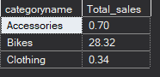

**Orders by Product Category:**

select p.categoryname, COUNT(distinct salesorderid) as Total_Orders

from products p

join orders o

on p.productid = o.productid

group by p.categoryname

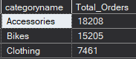

**Customer Count by Product Category:**

select p.categoryname, COUNT(distinct customerid) as Total_customers

from products p

join orders o

on p.productid = o.productid

group by p.categoryname

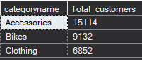

**Quantity Sold by Product Category:**

select p.categoryname, SUM(orderquantity) as Total_Quantity

from products p

join orders o

on p.productid = o.productid

group by p.categoryname

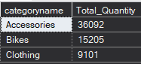

**Average Order Value by Product Category:**

select p.categoryname, sum(linetotal) / COUNT(distinct salesorderid) as Avg_Order_Value

from products p

join orders o

on p.productid = o.productid

group by p.categoryname

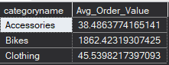

**Average Unit Price by Product Category:**

select p.categoryname, AVG(unitprice) as Avg_Unit_Price

from products p

join orders o

on p.productid = o.productid

group by p.categoryname

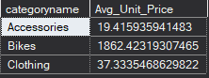

**-----------------------------------------------------------------------------------------------------------------------------------------------------------**

**Sales by Product SubCategory:**

select top 10 p.subcategoryname, cast(sum(linetotal)/ 1000000 as decimal(10,2)) as Total_sales

from products p

join orders o

on p.productid = o.productid

group by p.subcategoryname

order by Total_sales desc

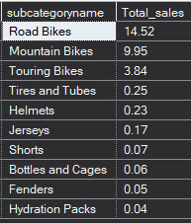

**Orders by Product SubCategory:**

select top 10 p.subcategoryname, COUNT(distinct salesorderid) as Total_Orders

from products p

join orders o

on p.productid = o.productid

group by p.subcategoryname

order by Total_Orders desc

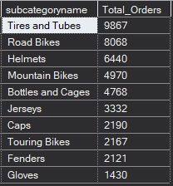

**Customer Count by Product Subcategory:**

select top 10 p.subcategoryname, COUNT(distinct customerid) as Total_customers

from products p

join orders o

on p.productid = o.productid

group by p.subcategoryname

order by Total_Orders desc

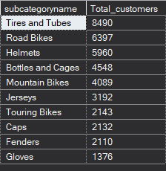

**Quantity Sold by Product Subcategory:**

select top 10 p.subcategoryname, SUM(orderquantity) as Total_Quantity

from products p

join orders o

on p.productid = o.productid

group by p.subcategoryname

order by Total_Quantity desc

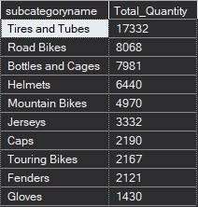

**Average Order Value by Product Subcategory:**select top 10 p.subcategoryname

, cast(sum(linetotal) / COUNT(distinct salesorderid) as decimal(10,2)) as Avg_Order_Value

from products p

join orders o

on p.productid = o.productid

group by p.subcategoryname

order by Avg_Order_Value desc

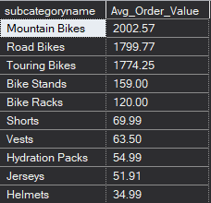

**Average Unit Price by Product Subcategory:**

select top 10 p.subcategoryname

, cast(AVG(unitprice) as decimal(10,2)) as Avg_Unit_Price

from products p

join orders o

on p.productid = o.productid

group by p.subcategoryname

order by Avg_Unit_Price desc

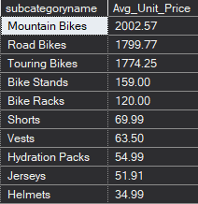

**----------------------------------------------------------------------------------------------------------------------------------------------**

**Sales by Productname:**

select top 10 p.productname, cast(sum(linetotal)/ 1000000 as decimal(10,2)) as Total_sales

from products p

join orders o

on p.productid = o.productid

group by p.productname

order by Total_sales desc

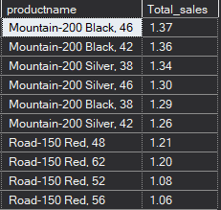

**Orders by Productname:**

select top 10 p.productname, COUNT(distinct salesorderid) as Total_Orders

from products p

join orders o

on p.productid = o.productid

group by p.productname

order by Total_Orders desc

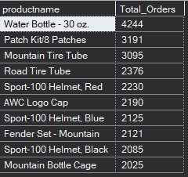

**Customers count by Productname:**

select top 10 p.productname, COUNT(distinct customerid) as Total_customers

from products p

join orders o

on p.productid = o.productid

group by p.productname

order by Total_customers desc

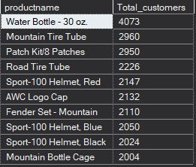

**QuantitySold by Productname:**

select top 10 p.productname, SUM(orderquantity) as Total_Quantity

from products p

join orders o

on p.productid = o.productid

group by p.productname

order by Total_Quantity desc

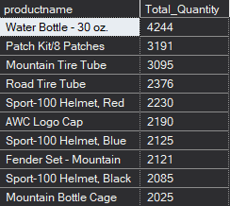

**Average Order Value by Productname:**

select top 10 p.productname

,cast(sum(linetotal) / COUNT(distinct salesorderid) as decimal(10,2)) as Avg_Order_Value

from products p

join orders o

on p.productid = o.productid

group by p.productname

order by Avg_Order_Value desc

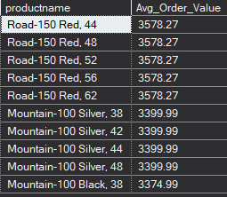

**Average Unit Price by Productname:**

select top 10 p.productname

, cast(AVG(unitprice) as decimal(10,2)) as Avg_Unit_Price

from products p

join orders o

on p.productid = o.productid

group by p.productname

order by Avg_Unit_Price desc

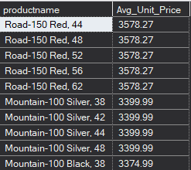

**----------------------------------------------------------------------------------------------------------------------------------------------Overall Sales by Orderdate in months:**

select

MONTH(orderdate) as Month_num

, DATENAME(month, orderdate) as Month_name

, cast(((SUM(linetotal)) * 1.0/ 1000000) as decimal(10,1)) as Total_Sales

from orders

group by MONTH(orderdate), DATENAME(month, orderdate)

order by Month_num asc

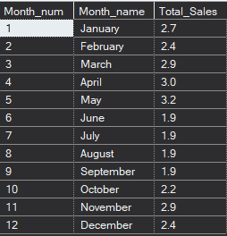

**Sales by Region (Country) in Millions:**

select c.country

, CAST(SUM(o.linetotal)/1000000 as decimal(10,2)) as Total_sales

, COUNT(DISTINCT o.customerid) as Customer_Count

from orders o

join customers c on o.customerid = c.customerid

group by c.country

order by Total_sales desc

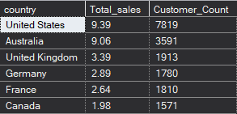

**----------------------------------------------------------------------------------------------------------------------------------------------**

**Sales by Region (Country and City) in Thousands:**

select c.country

, c.city

, CAST(SUM(o.linetotal)/1000 as decimal(10,2)) as Total_sales

, COUNT(distinct o.customerid) as Customer_count

from orders o

join customers c on o.customerid = c.customerid

group by c.country, c.city

order by Total_sales desc

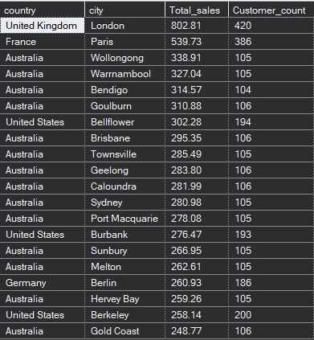

**B. ADVENTUREWORKS DASHBOARD | DETAILS**

SELECT c.customerid

,c.fullname

, c.city

, c.country

, cast(SUM(o.linetotal) / 1000 as decimal(10,1)) as Total_Investment

FROM customers c

join orders o

on c.customerid = o.customerid

group by c.customerid, c.fullname, c.city, c.country

order by Total_Investment desc

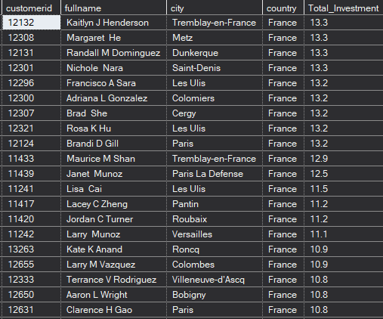

*Note: I had applied multiple Filters on all the dashboards. You can check the results for the filters as well by modifying the query.*